ASSIGNMENT-2

The Cognos HR Scorecard: Measuring Success in Talent Management

**Name:** Suryapraba V

**NM ID:** au611220104159

**Task 1:** Creating Dashboard

Step 1: Uploading the dataset

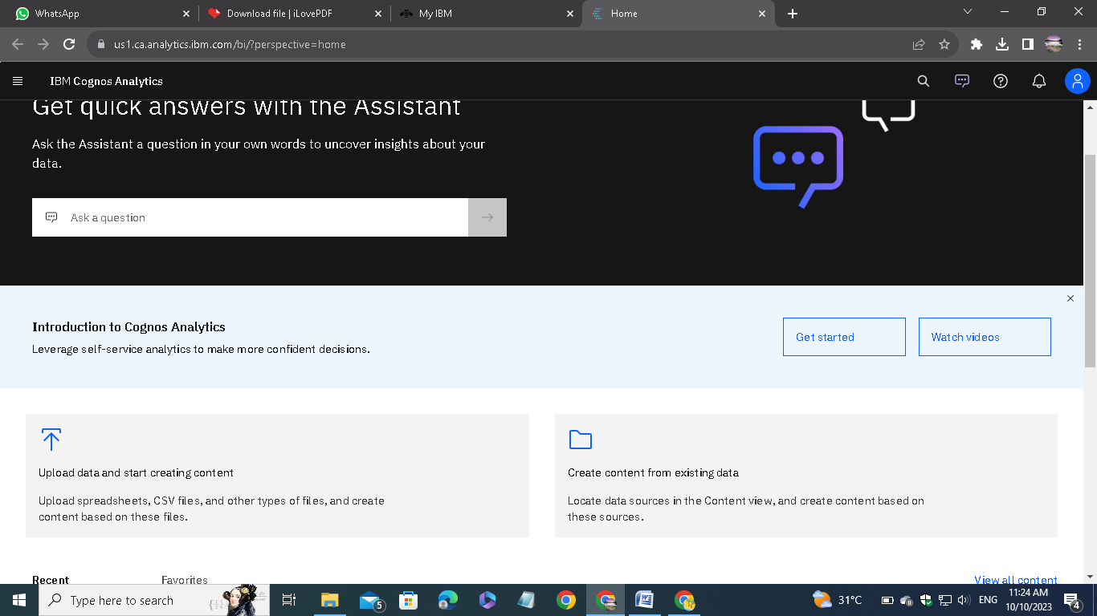

Open IBM Cognos Analytics. Then choose upload data.

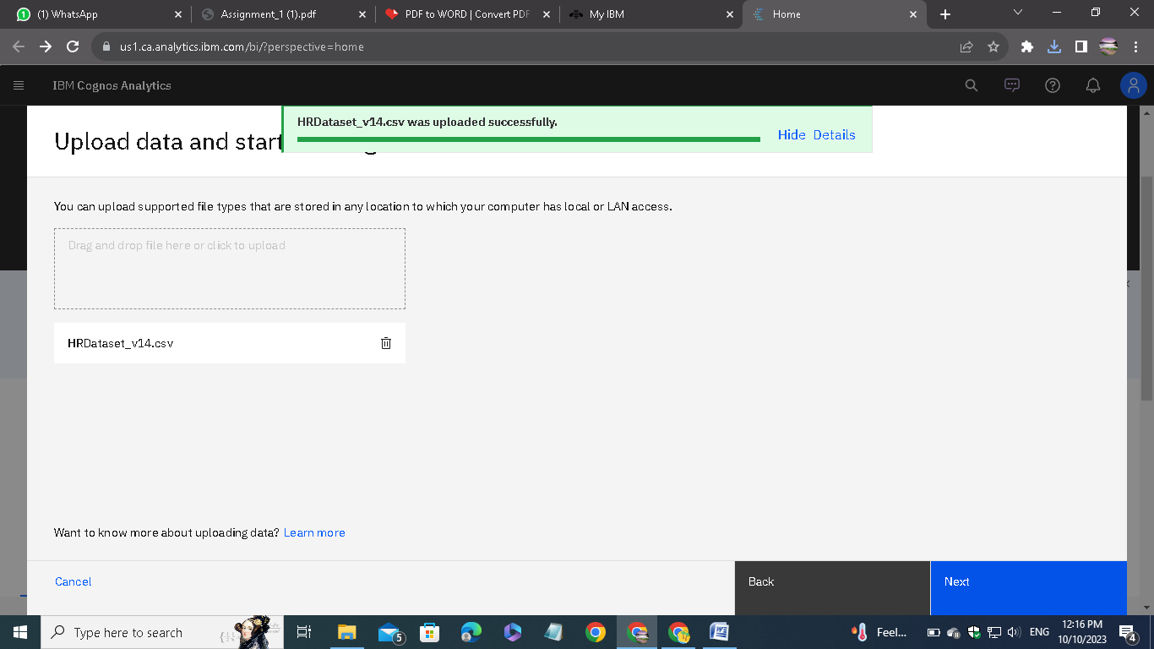

Upload the CSV data file which we downloaded from the given link on the assignment.

Step 2: Preparing the dataset

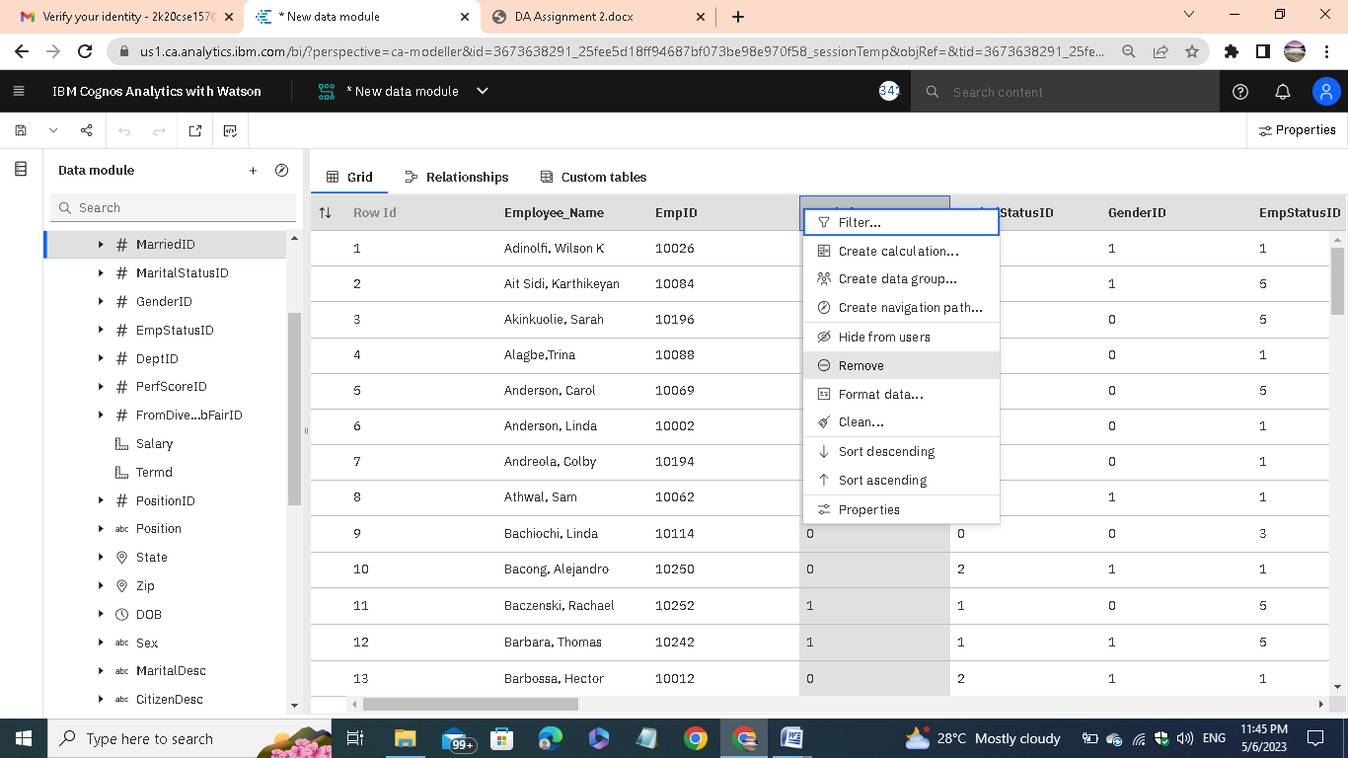

Remove the unnecessary columns and check for the missing values. In my case, there are no missing cases.

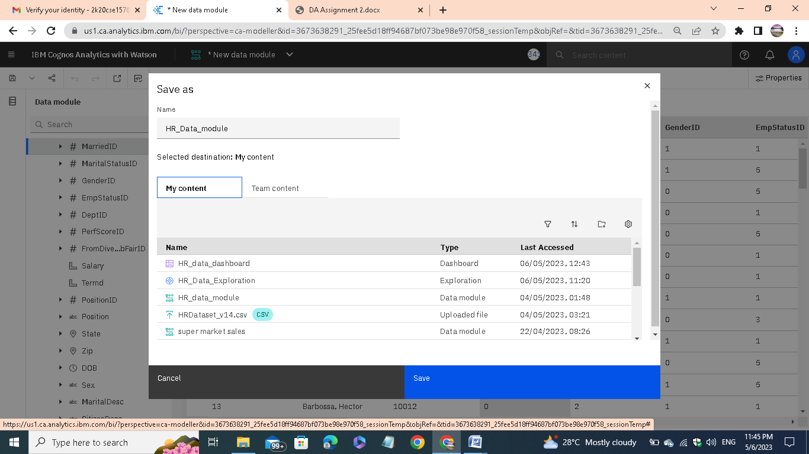

After removing, save the new data module in a required name.

Step 3: Exploring the dataset

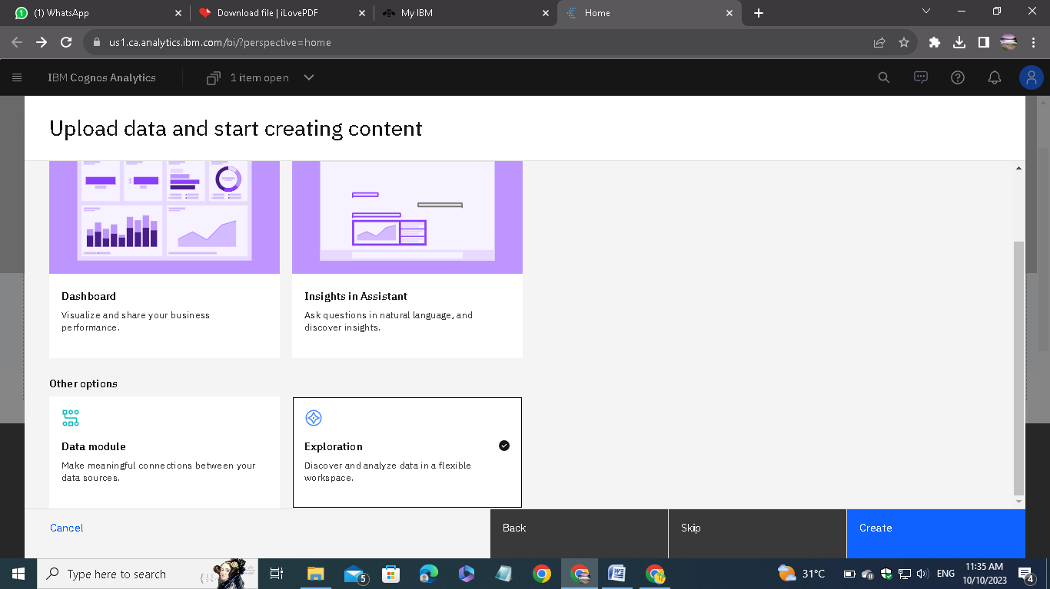

Go to Exploration given in the menu and open the saved data module.

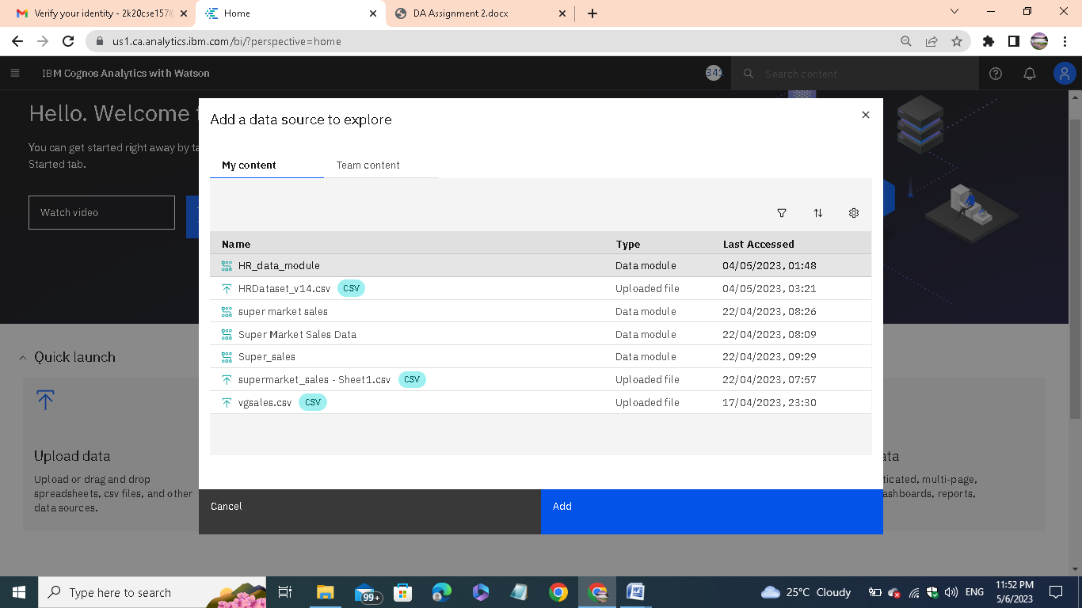

Then add the data module to the Explorations.

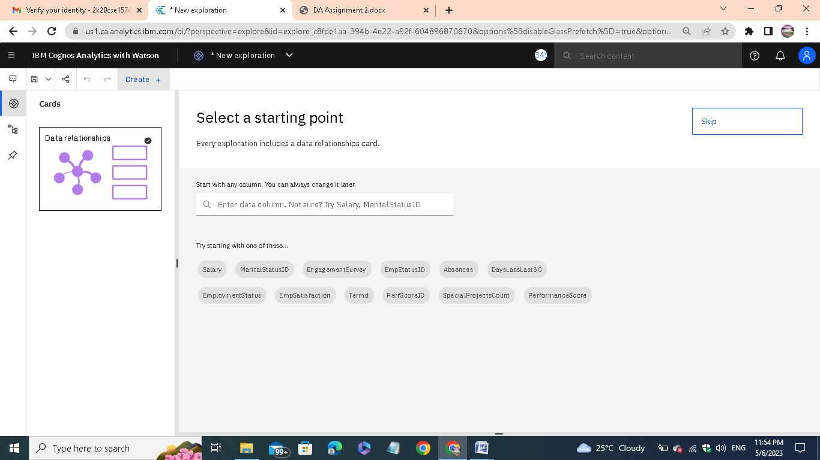

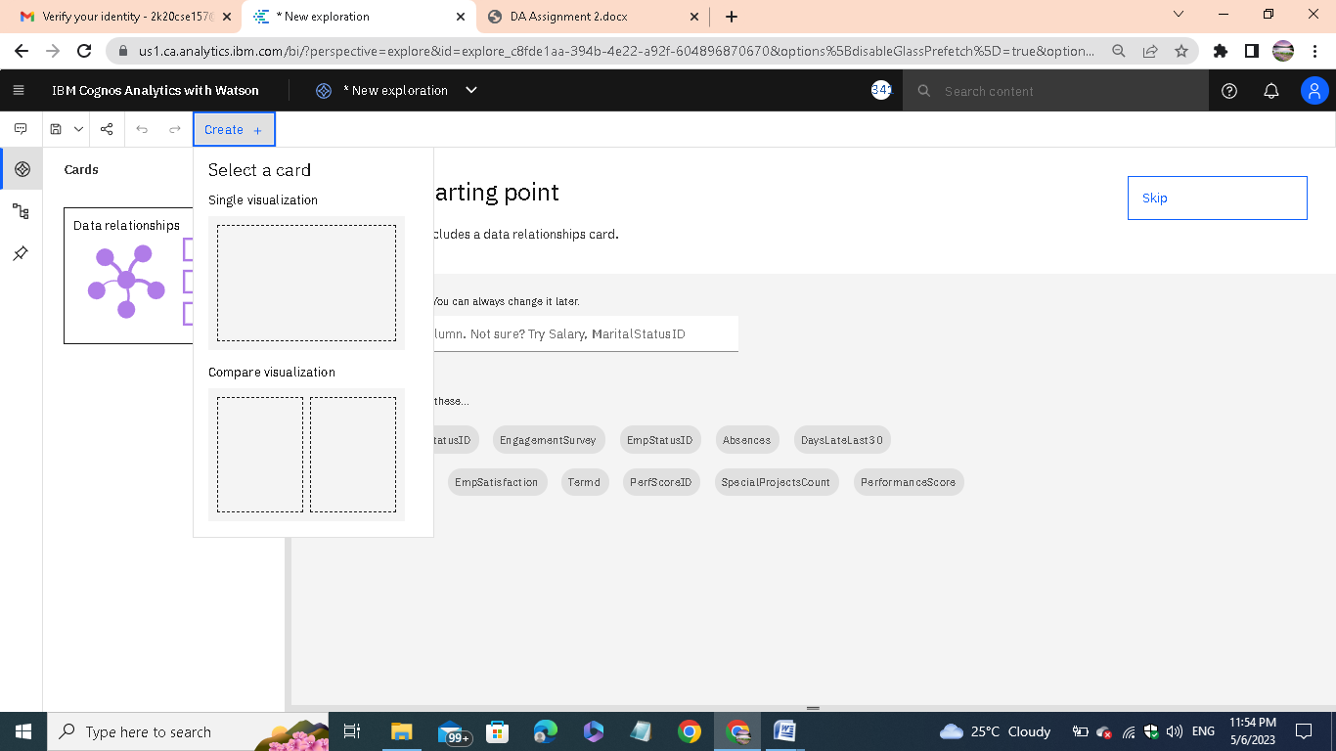

Click on create and select a card. In my case, I have chosen the single visualization.

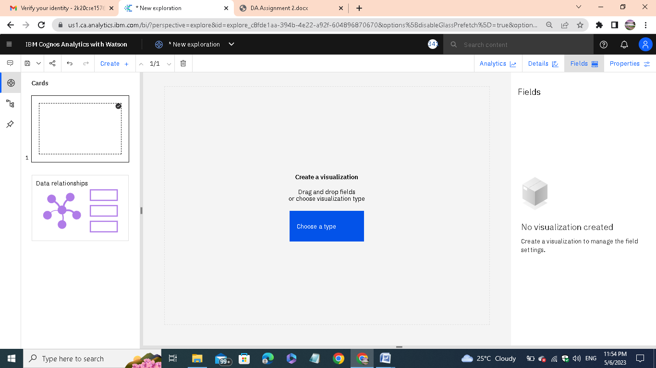

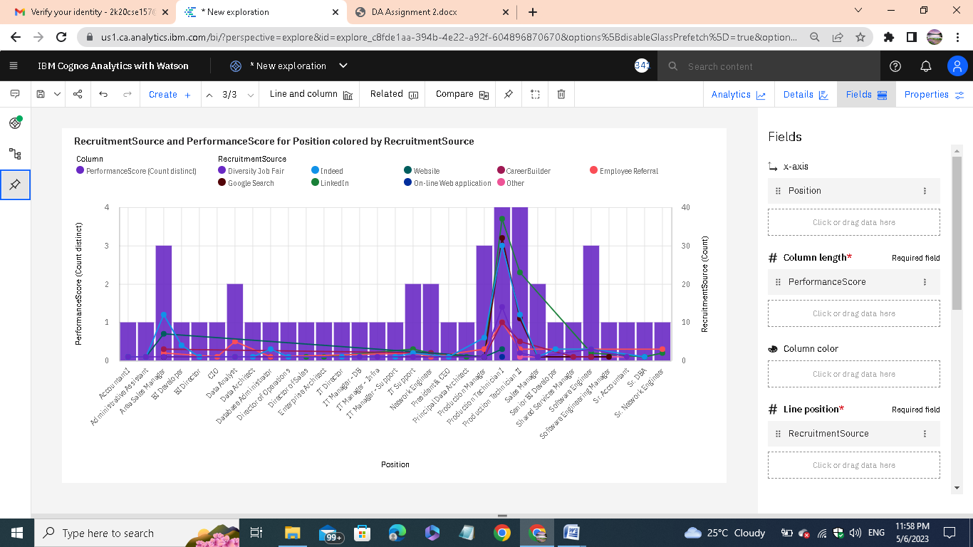

Then choose the type of the visualization. Each type of visualization is used for different needs.

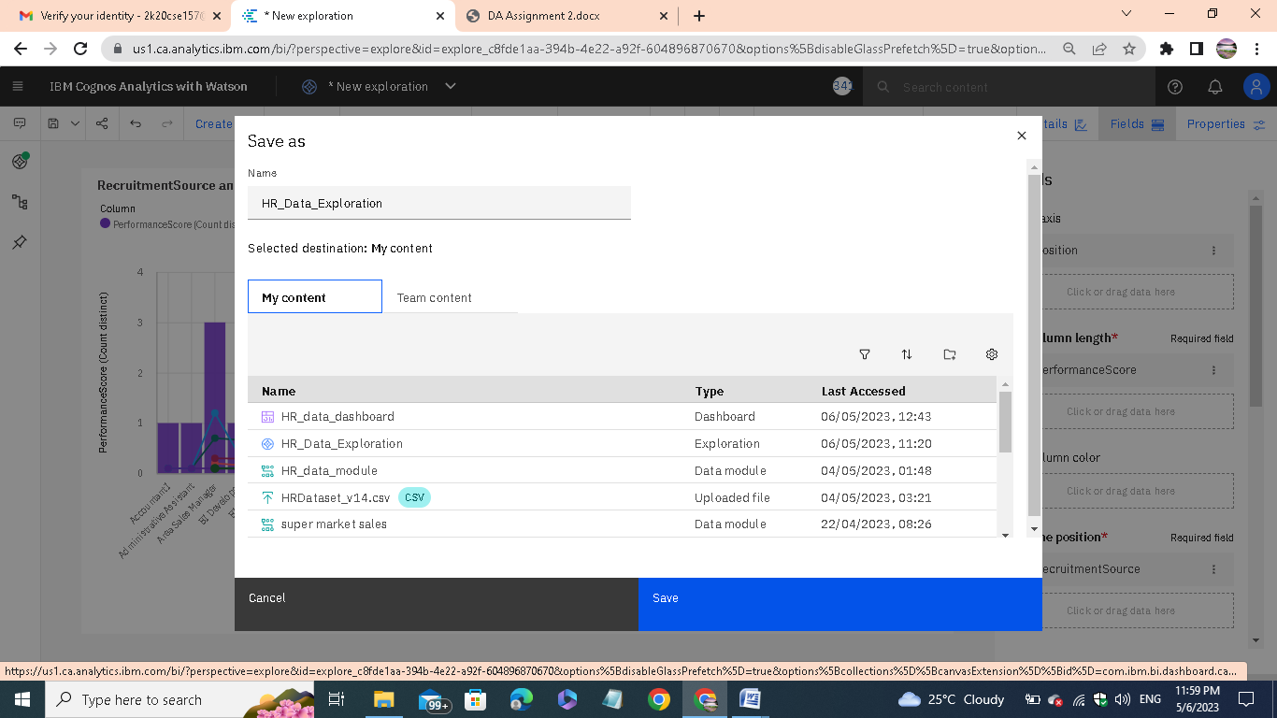

After exploring save it in a required name.

Step 4: Presenting the data

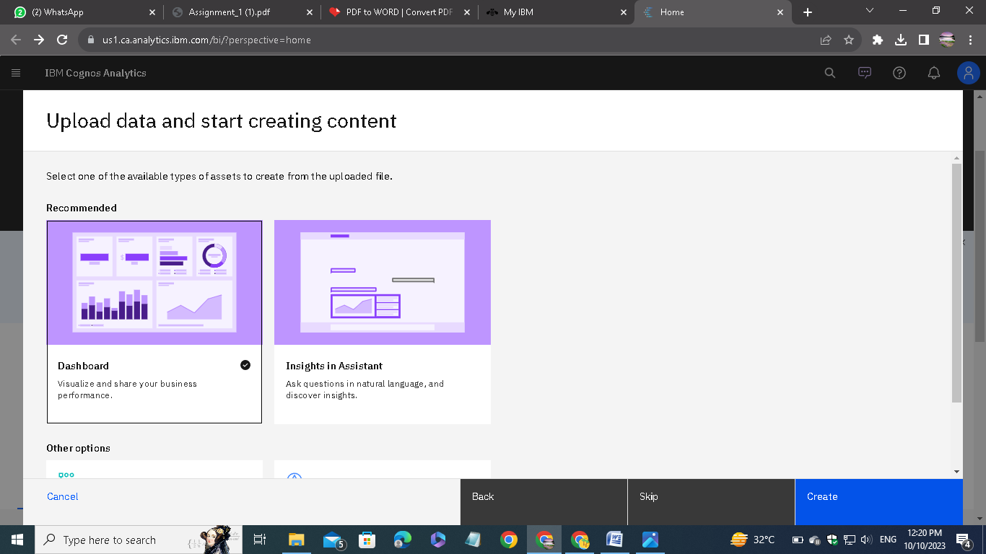

Choose the dashboard.

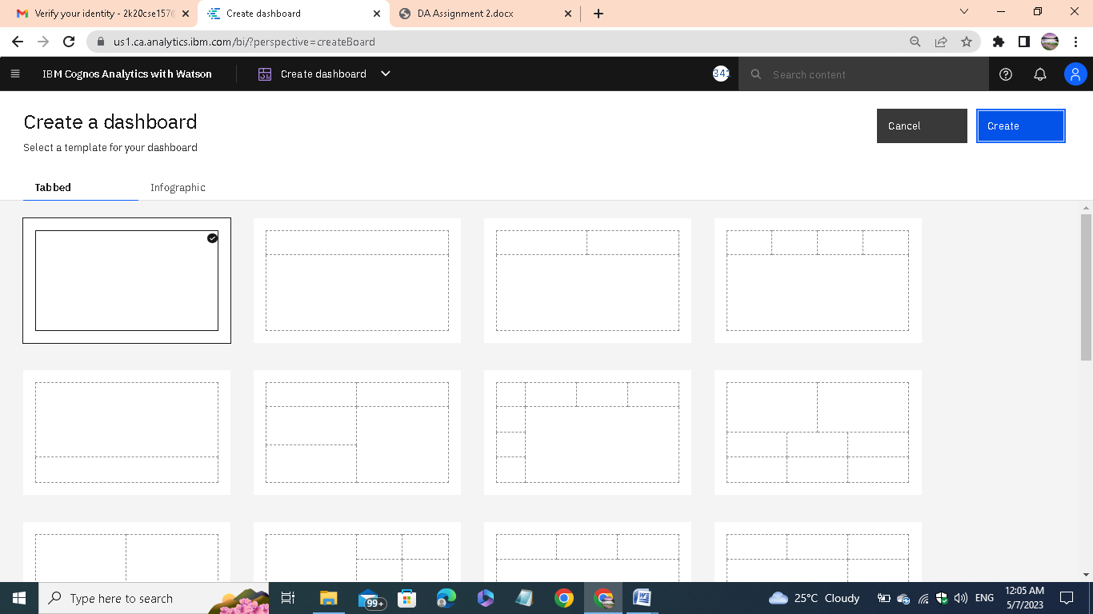

Then select a type of dashboard and create it.

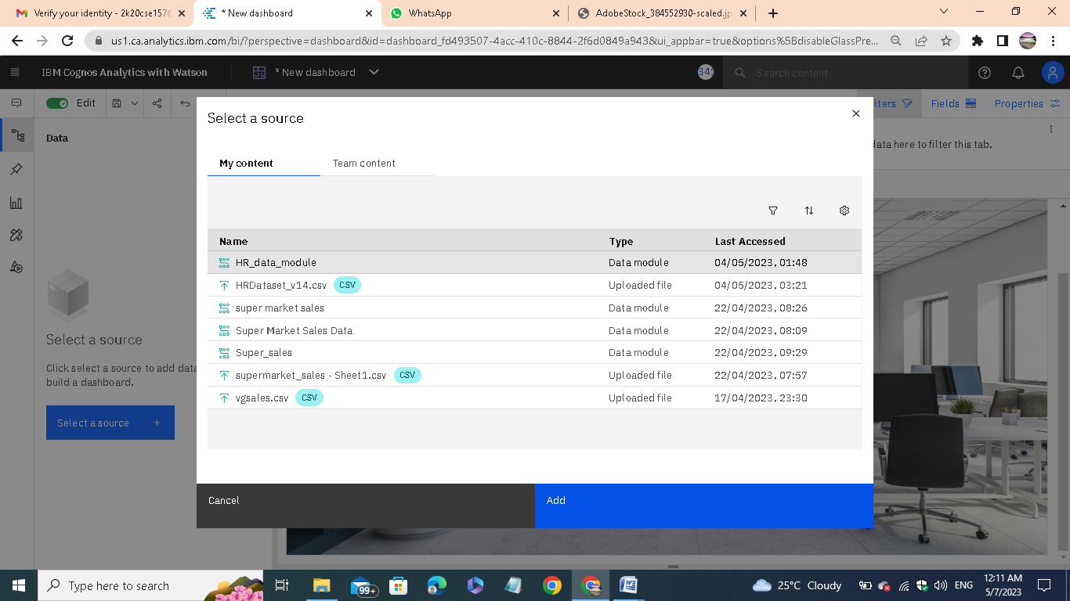

Add the source file to the dashboard. Adjust the dashboard settings for our convenience.

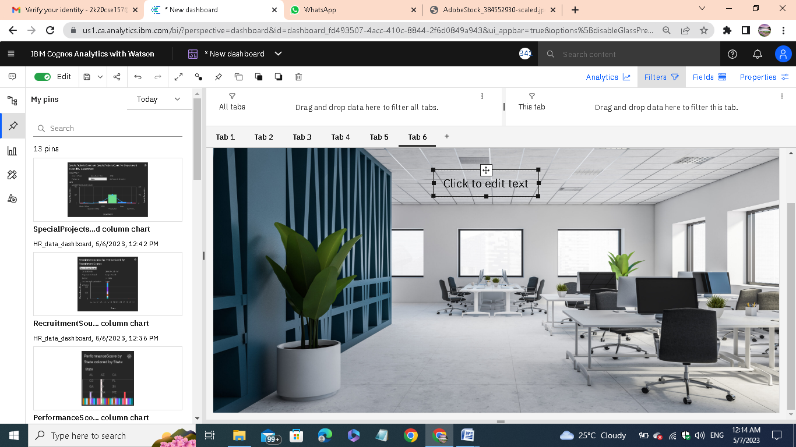

We can able to directly drag the data from the source or we can also able to plot our exploration directly from the pinned things.

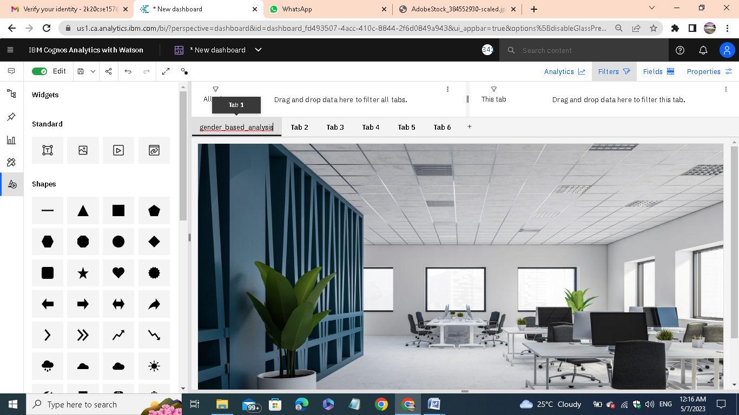

Change the tab name for our reference.

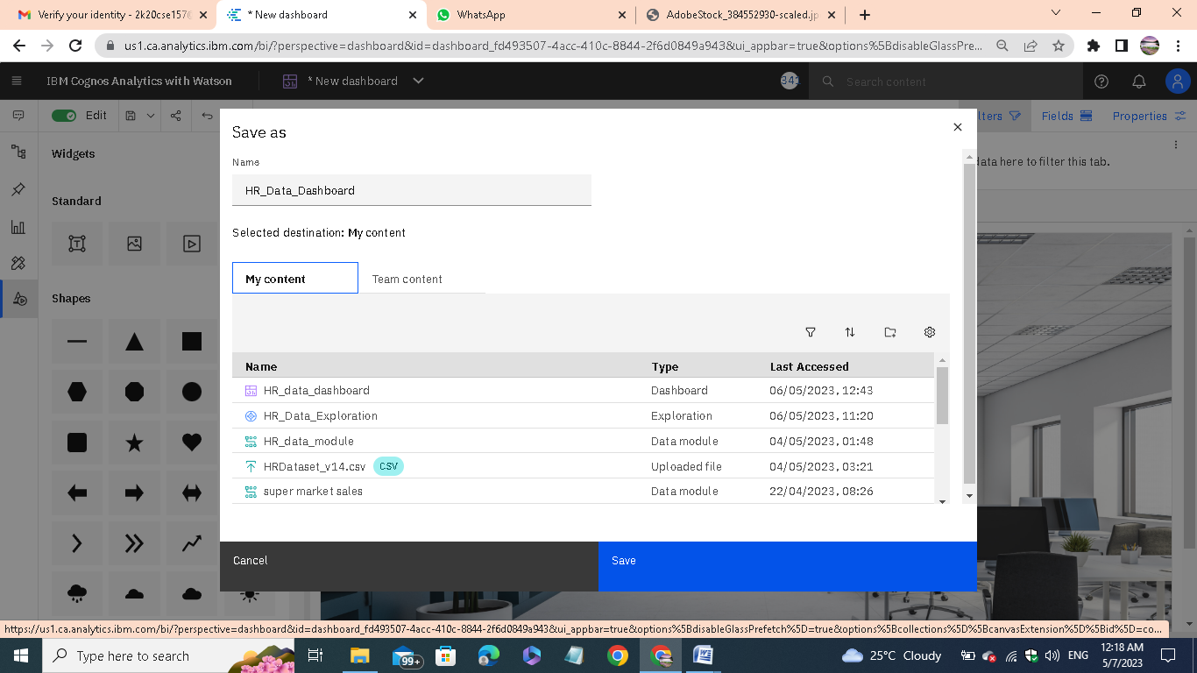

After that save the presentation. These steps are followed for all other tabs. Finally we get the visualization of our analytics.

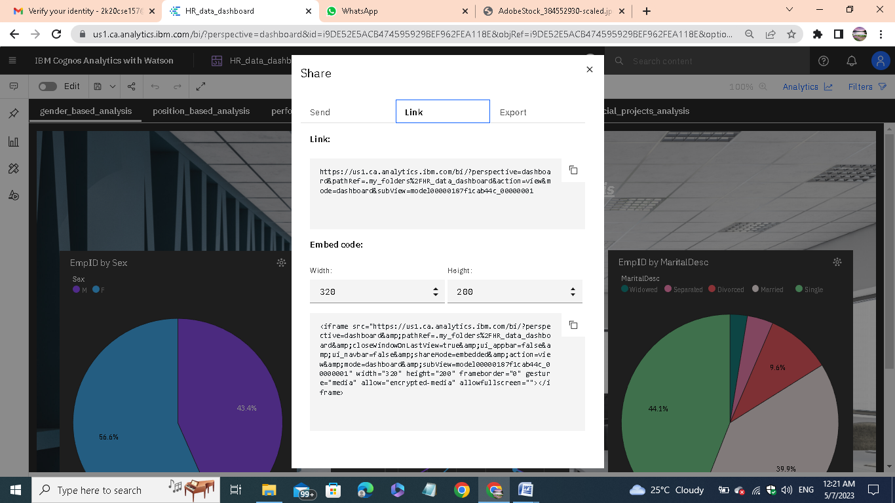

Using share option, we can able to share our presentation as direct link or the Embed code.

Here I am attaching the screenshots of all the tabs I have created:

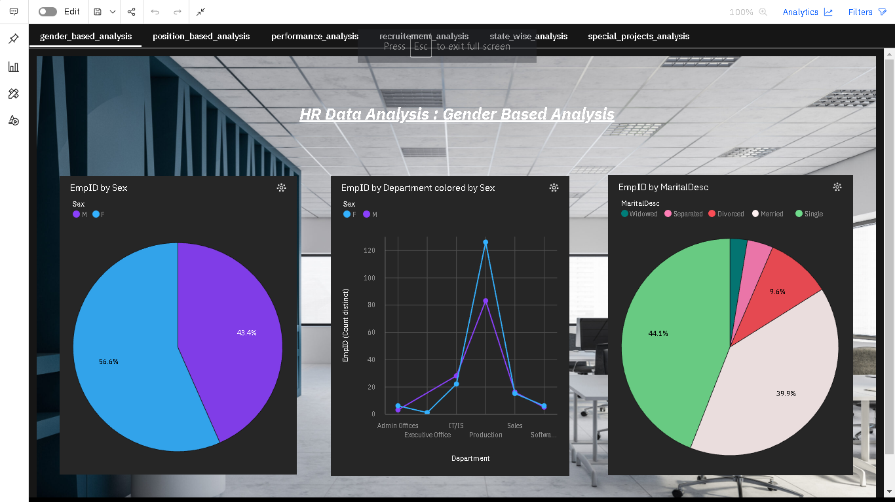

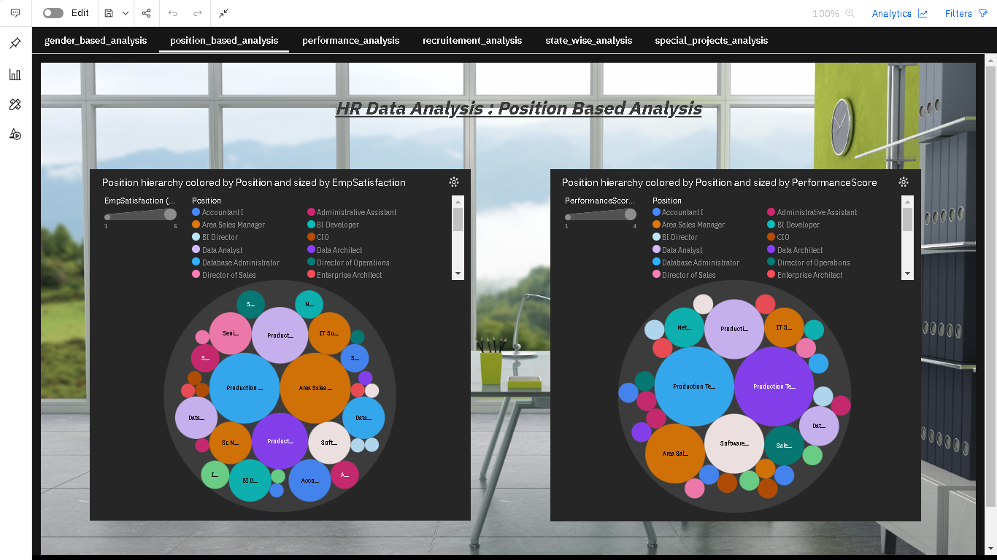

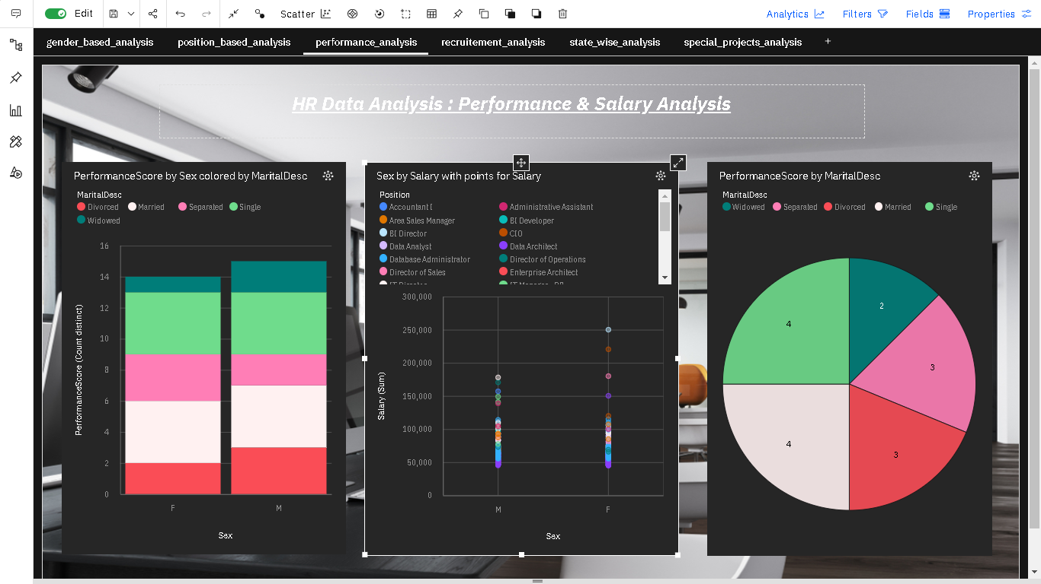

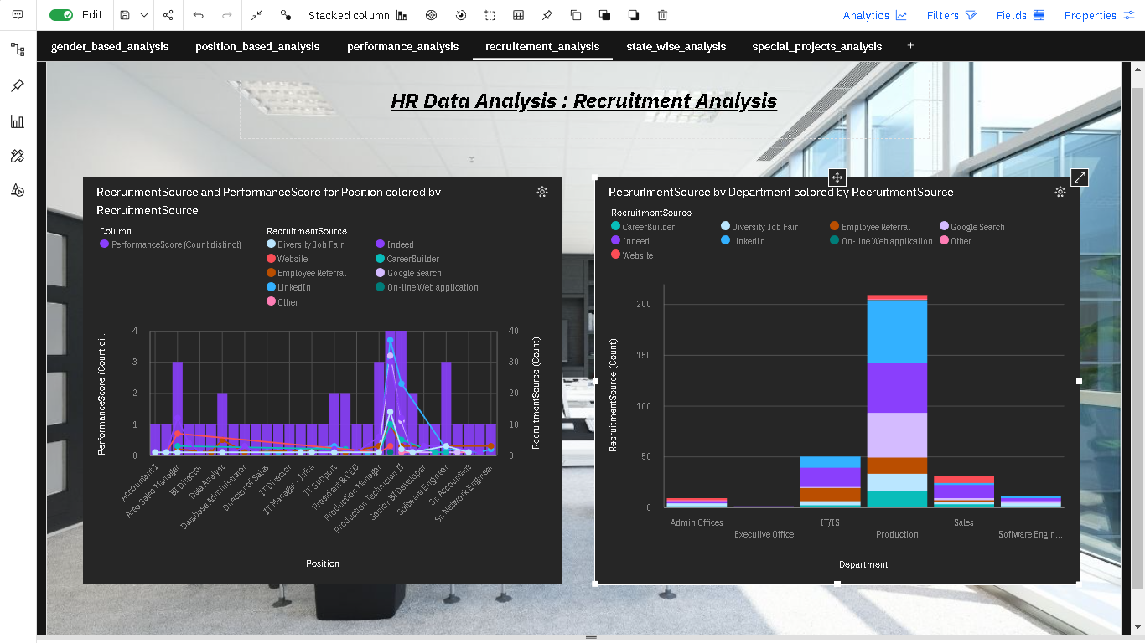

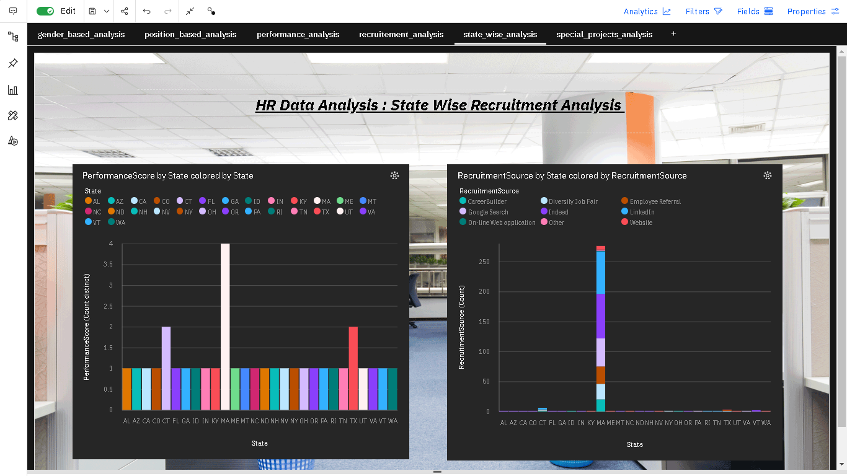

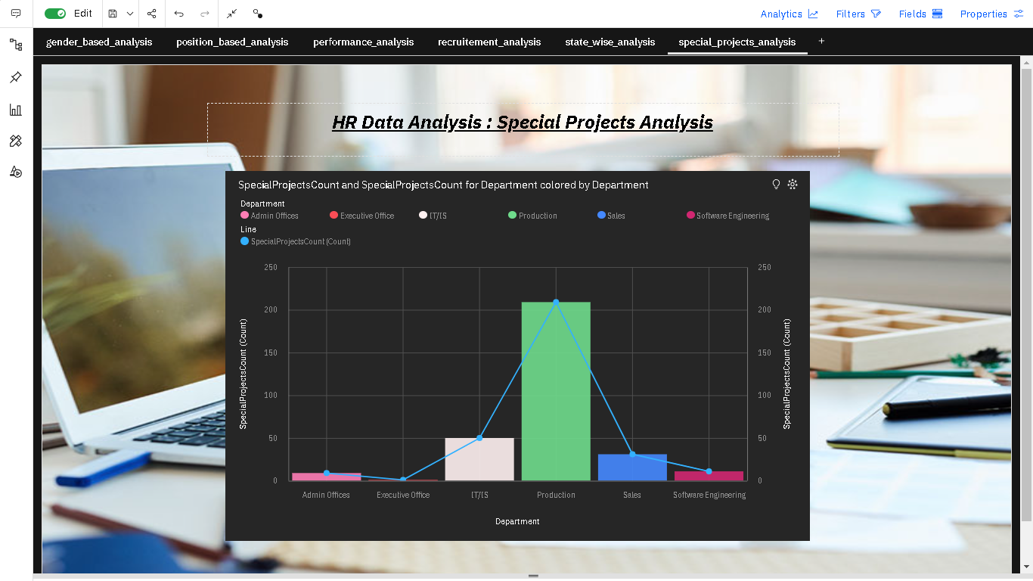

**Task 2:** Creating Report

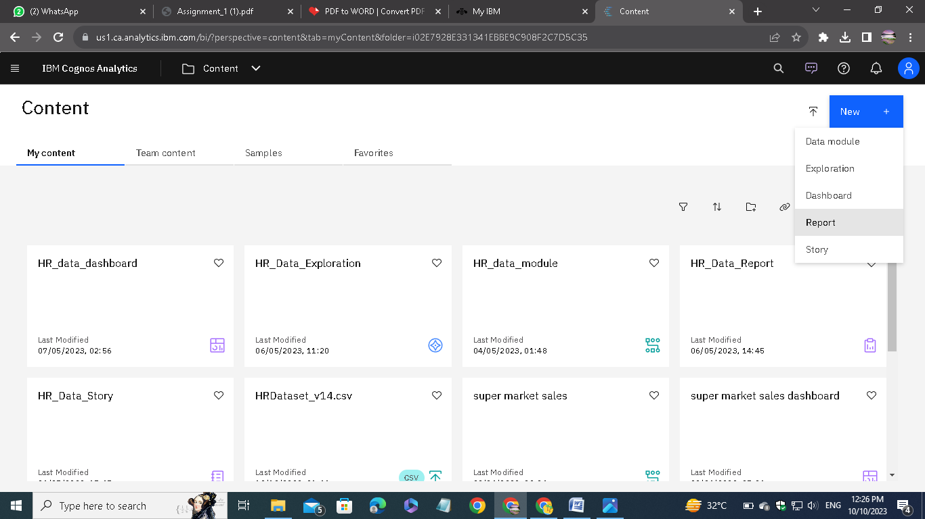

For creating report, choose the Report option.

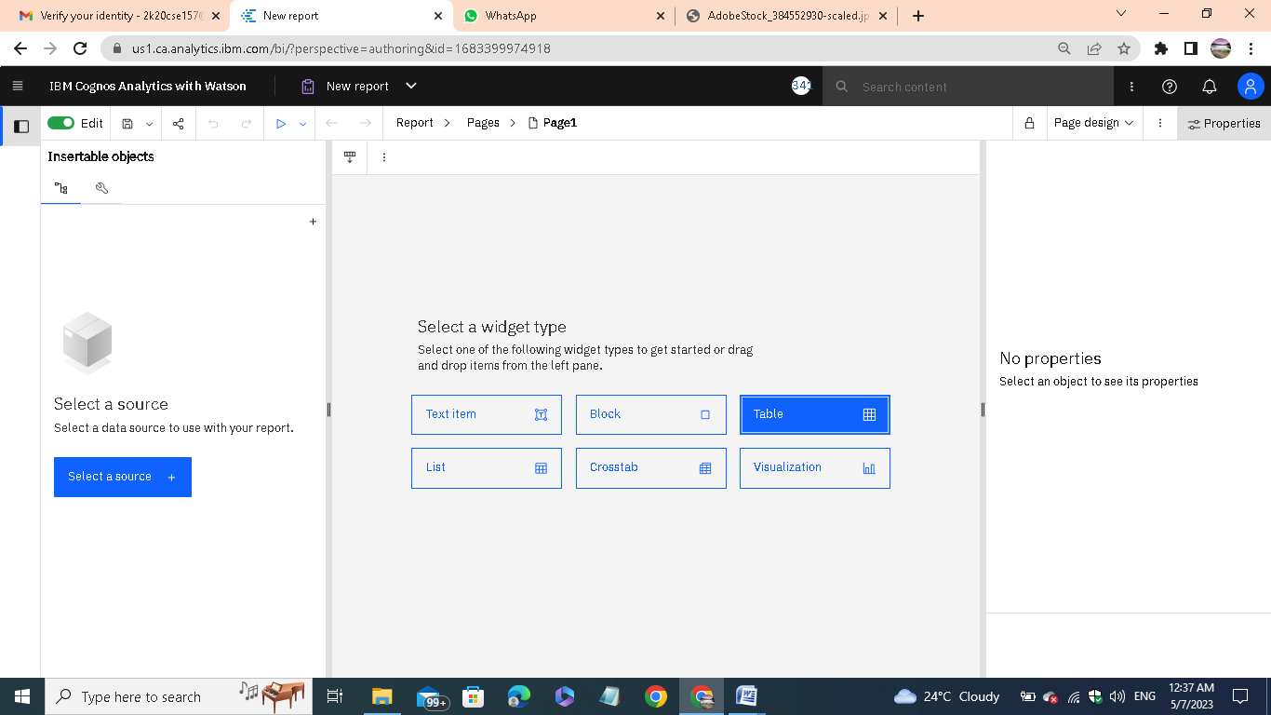

Select a widget type that used for creating report.

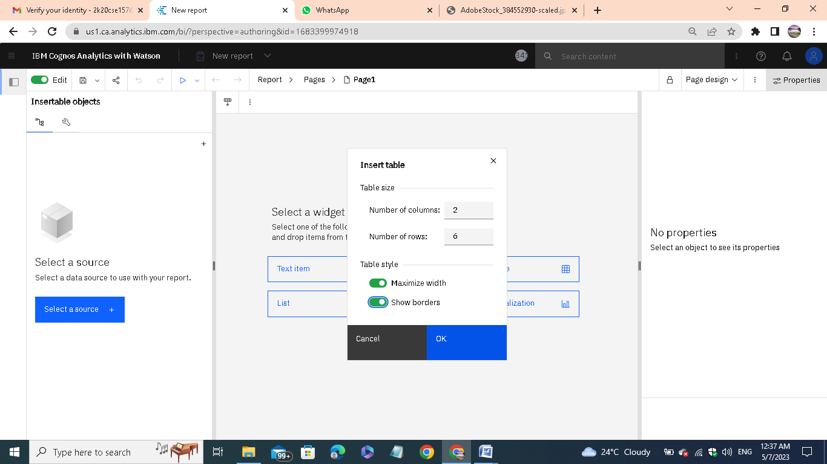

In my case, I am choosing table type of the report.

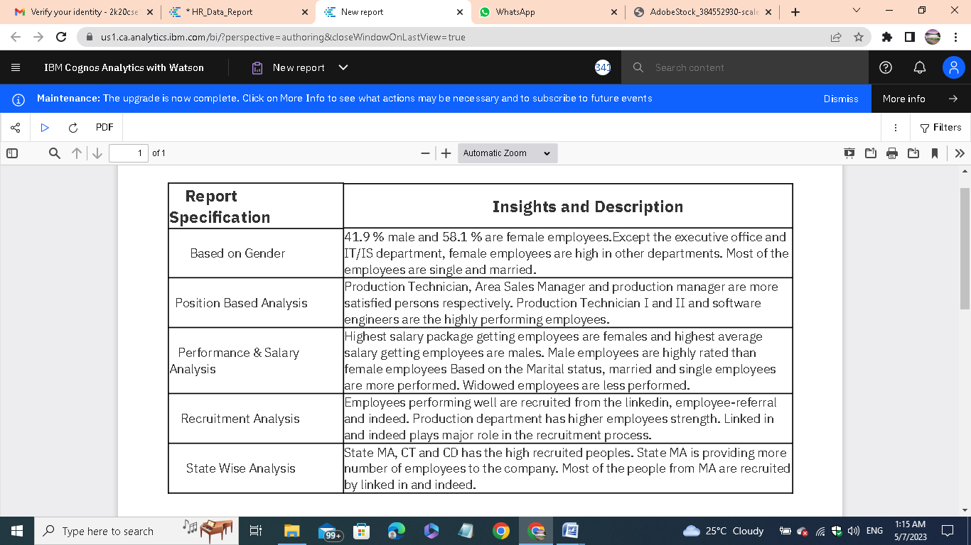

After creating report, we can run using multiple options. Here I am running as PDF format report.

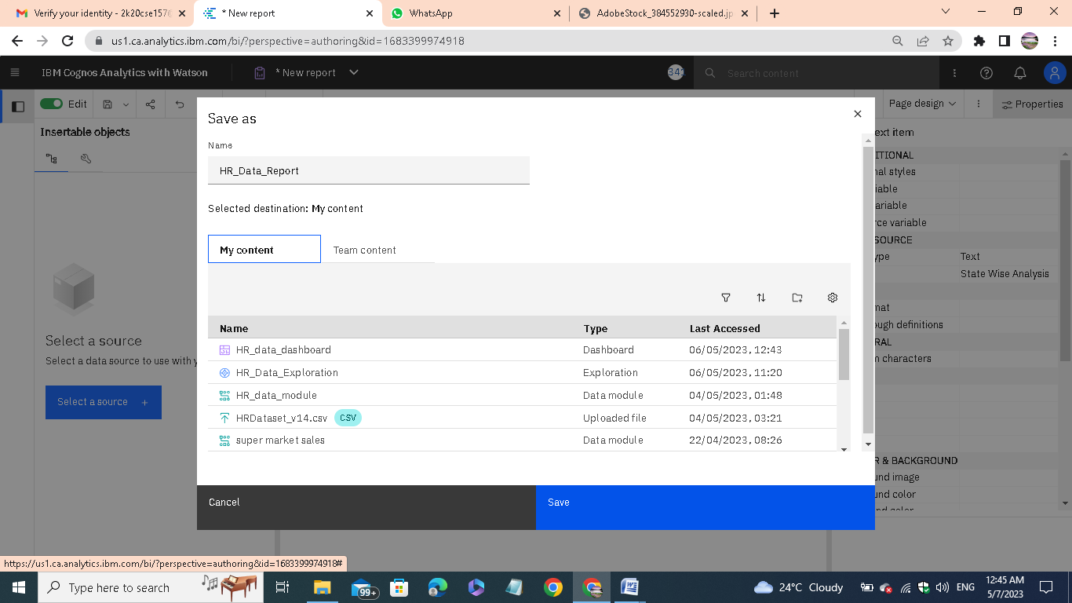

Save the report using required name.

**Task 3:** Creating Story

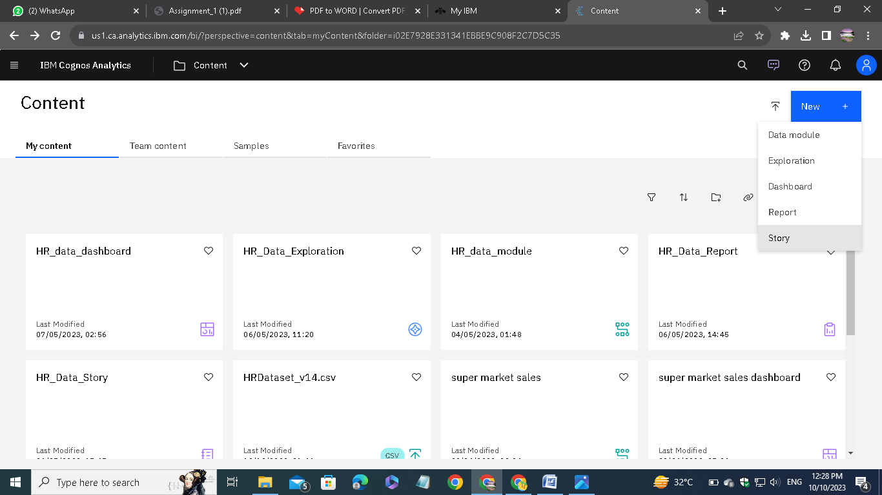

To create a story, choose the Story option.

# Screenshot (264).png

# These tools are similar to the other presentation creating tools.

# Screenshot (265).png

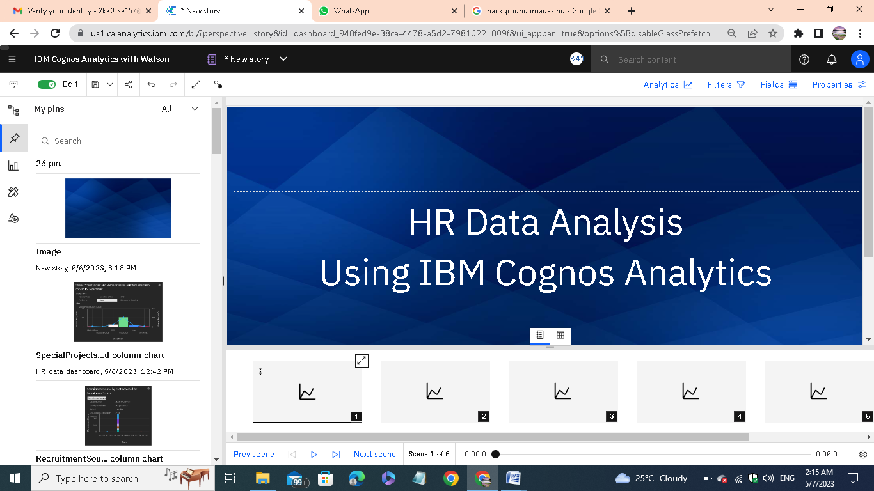

Here is the completed Story:

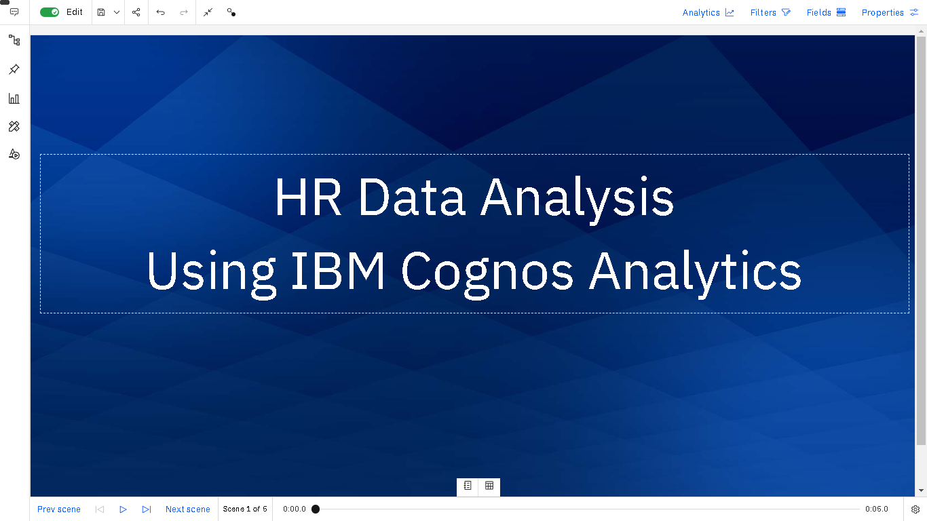

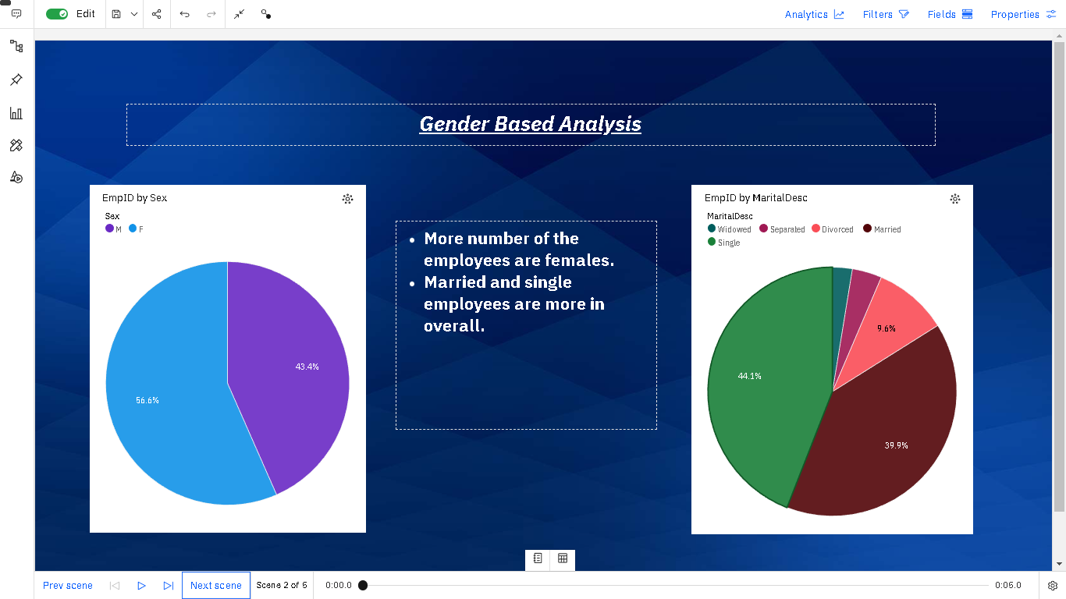

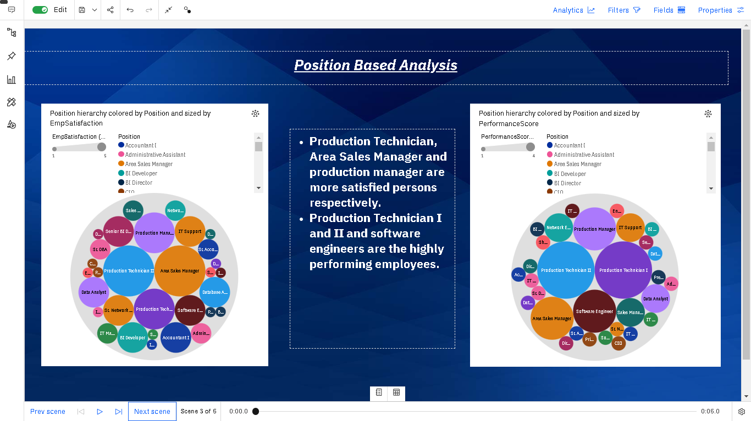

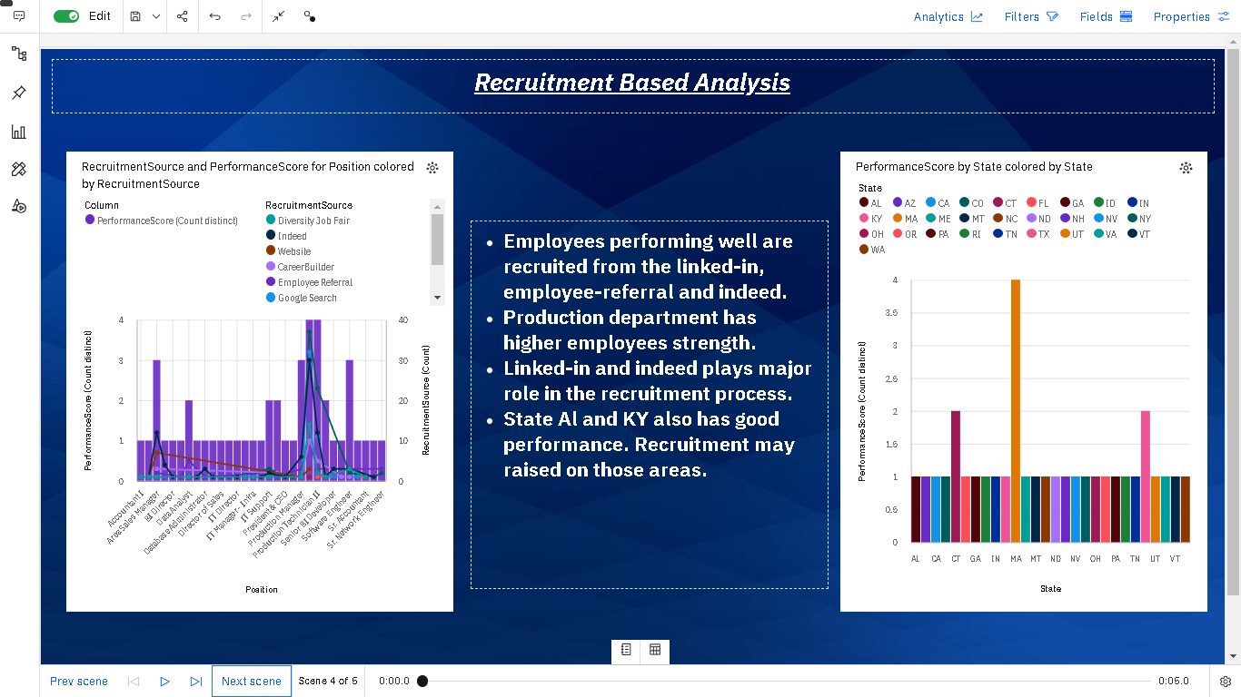

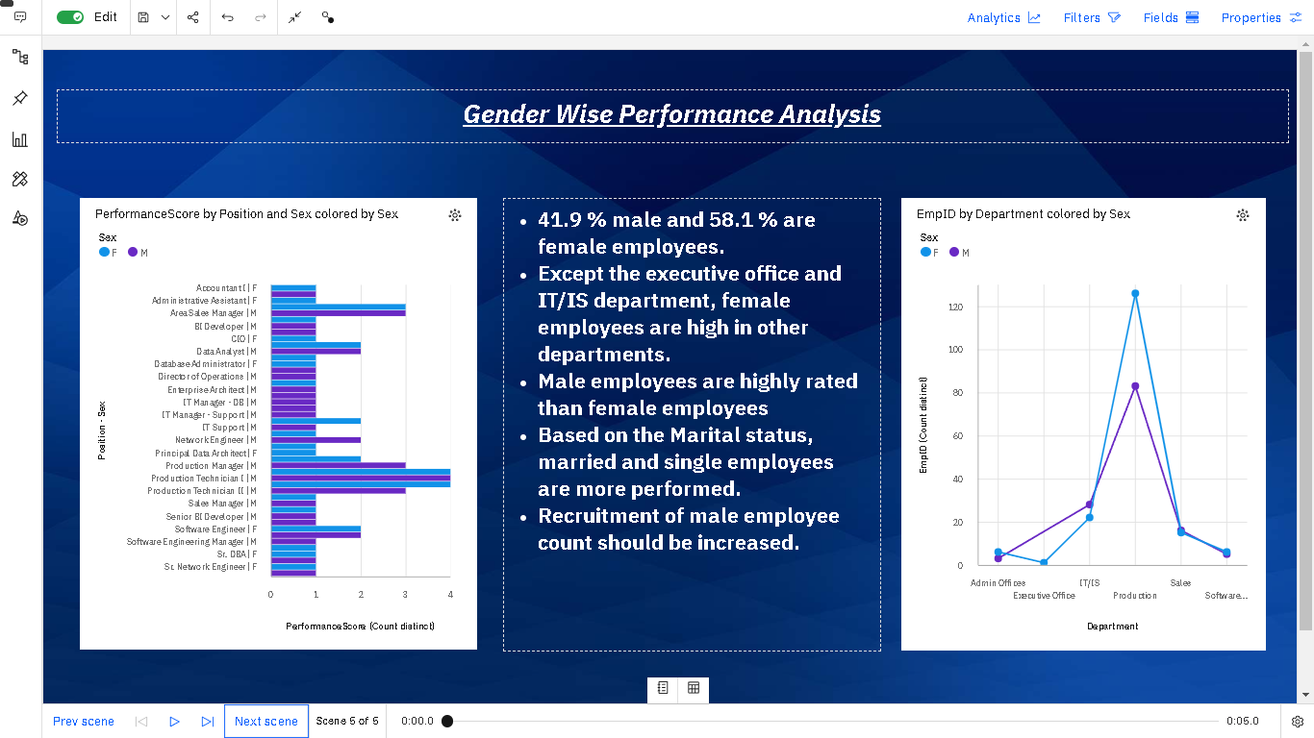

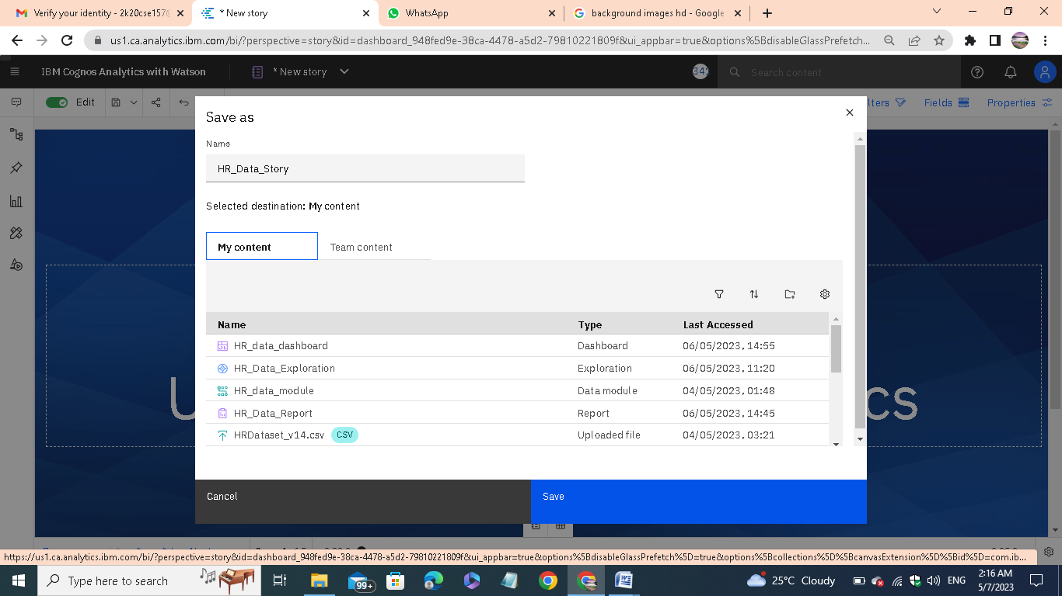

Save the story as per the required name.

Finally make sure everything has been saved.